# ViewMaster Slide

The document **GTML File Format** located in $PTD/doc directory.

I’ve finally did a clean Eclipse build on my MacBook. Apparently, I skipped the “src” directory; as a result, there is a required extra step to rename the package directory to be the root of an “empty” head.

# PTD Release Documents

Normally in a distributed Java sources you have a “src” with **Package Directory** and Java files placed accordingly to the **Package Directory**.

For example, the $PTD should have src/releasetools/PepMan.java and src/starship/StarShip.java. However I’ve separated the modules and have the source files after the module. For example, I would have $PTD/PepMan/releasetool/gui/PepMan.java.

If you import the sources you have to create your own “src” with $PTD as the **Eclipse Workspace**.

In my next release, I will have the “src” after PepMan and other modules. That removes the extra step to rename the null empty header.

I will also add ant scripts for command-line builds. As I add Multi-Platform I need the jar file library shared.

# GTML File format

Synopsis:

Book creation has just leveled up. With the arrival of GTML (Generation Two Mark Up Language), digital books reach the mass.

This document describes the file format for xml and html files for Books, Chapters, and Pages.

Both Books and Chapter have attributes specified in xml format while the Pages are specified in html format.

All three are packaged in sub-directory of ‘gtml’. The platform to load the GTML files is called PepMan which stands for Package Manager.

PepMan can load up the files in three modes: Working Directory, Jar Files, and Sandbox.

Once loaded, PepMan displayed the attributes for Books in the ‘GTML’ tab of the Properties Dialog. The extended information is displayed in a Extended Frame.

To navigate around the Pages in the JTree in the Extended Frame. There are three types of data structure for the Book in the Extended Frame: Core Data, Borderline Annotation, and Flatline.

The attributes for Books are as follows. The attributes for Chapters are: H1, H2, etc. The optional attributes are Page-Range.

The content for Page is the same as the web pages in html. They include <p> for paragraph, <table>, and <li> for lists. Mostly, <p> is the main anchor for pages. All attributes are specified according to the HTML 1.0 specification. The reason is that the pages are rendered using JEditorPane which is compliant with the HTML specification.

The naming convention for all three components—Books, Chapters, and Pages—follows according to the file naming structure separate by “.” Into three groups. The first group is the **Structure** **Type**. They are **Book** for Books, **Chapter** for Chapters, and **Page** for Pages.

They are case sensitive and can only be all lower-case or the first letter is capitalized. If there are any discrepancies, they can be annotated in the Extended Frame.

To summarize, all three Components are specified using the following regular expressions for Books, Chapters, and Pages respectively.

private final static String ALPANUMERIC_Group = "([a-zA-Z0-9]+)";

private final static String NUMERIC_Group = "([0-9]+)";

public final static String BOOK=

"(BOOK|Book)\\."+

ALPANUMERIC_Group+"\\."+

NUMERIC_Group+

"\\.xml"

public final static String CHAPTER=

"(CHAPTER|Chapter)\\."+

ALPANUMERIC_Group+"\\."+

NUMERIC_Group+

"\\.html"

public final static String PAGE=

"(PAGE|Page)\\."+

ALPANUMERIC_Group+"\\."+

NUMERIC_Group+

"\\.html"

# Hi Jack

Hello U and I

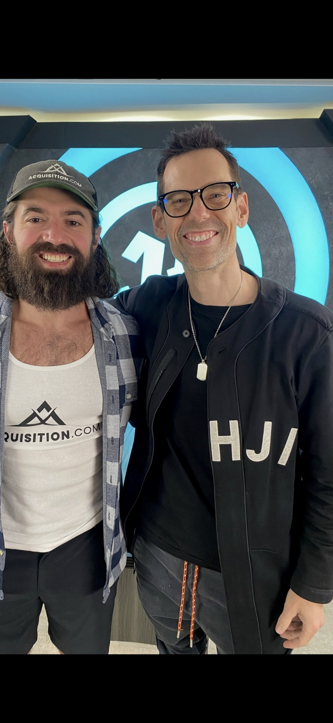

Figure i. Hi Jack

# Slide Lyrics Pullout

* [Slide lyrics pullout](https://youtu.be/M8m6DWuuZoU?si=YhnfUYkZ3pG7nBU-)

# Acquisiton.com headquarter

7 is a lucky number for IU. 42 is the mystery of the universe. 8 is what IU says when she is frustrated at the computer. She goes, “AHY, AHY , AHY”. Your anus ate Pluto.

* [7-42-8](https://www.facebook.com/reel/590105636980632?mibextid=wwXIfr)

# Pump and Extend

In order to **Time Schedule** (TS) with your cutesty partner, make you are **Pump** and **Extend** your time. An example of what not to do with her **Squeezed Time**. Do not **Poke Her Face**. Rather you want to give her a big fat kiss on the cheek.

Go the Tony Robbins way. Do not be **Missing in Action**. Take **Massive Action**. Listen to Tai Lopez. **Grab** one of those **Hand Squeezers** from him. Farm those **Karrots** like your life depends on it because it does. Learn from the big guys. When you **Acquire** beyond 14 of them, you are **Admired**. Use all your **Timed Scheduled** moment to take a look. When she is breastfeeding, you see that it **Pumps** and **Expands**.

Elon puts on Kekius Maximus notice.

[Kekius Maximus](https://www.msn.com/en-us/lifestyle/shopping/elon-musk-uses-a-1-799-curved-gaming-monitor-in-his-doge-office/ar-AA1Bp9eu?ocid=BingNewsSerp) (lolz =🡺 kekkk)

# Plastic Tornado and Seafloor Octopus

**Plastic Tornado’s** music reactant is rendered onto the **Droid’s Internal Projector**. The **Motion Vectors** can be share and dispatched using **Multi-Platform** sharing feature. A remote user can send a Book with a Page to order the food using **Label Algebra** and **Cube Control** to the McDonald’s Kiosks.

**Seafloor** is a **Private Parallel Virtual Machine** with the byte-array fanning out like a windmill to allow **Sinusoidal Anti-Collision Propagation Handshake** **Mechanism** for **Skyline**. **Skyline** uses **Black Nole** as the **Public Parallel Virtual Machine Gray Tunnel**. **Gray Tunnel** are **Virtual Freeways** for flying cars using **Sinusoidal Anti-Collison Propagation Handshake Mechanism**. This **PVM Fanning Protocol** allows remote sharing where two people using their PepMan connect via Private Realm before the **Motion Vector** is displayed in the **Droid Internal Projector** before the **Book** **Documents** are handed to the **McDonald’s Kiosk**. The **Book Documents** uses **Label Algebra** for the finalized transaction. The data exchange for **Seafloor** is a byte-array that fans out periodically—say like 10 frames per second. It is converted to a **Polar Coordinates** to be shared C8 (Coke Cola Cube Control x 2) **Seafloor Octopus**. **Seafloor Octopus** is Screen Sharing on the **Droid Internal Project**.

I will release **Plastic Tornado Music Reactant** where the sound is Rendered in in **Polar Coordinates** for **Spatial Audio** **Display for Seafloor Octopus**.

**Seafloor Octopus** is a command-line interface for the Master Machine to dispatch Slave Machines for byte-array parallel processing. It works in both X-Y Coordinates or **Polar Coordinates**. Think of it as a **Screen Sharing** for **Music Reactant for Plastic Tornado**.

* [Nvidia and Disney unveil smart and cute 'Star Wars' droid](https://www.usatoday.com/videos/tech/2025/03/21/nvidia-and-disney-unveil-smart-and-cute-star-wars-droid/82592297007/)

# Email Sender

@andrewschulz by PDB Podcast

# Posters at McLaren Park

* [Posters: Book tour by Lewis Howe](https://www.youtube.com/watch?v=HFGBJhrldxc)

# Measles outbreak

* [The number of cases just hit 350!](https://www.cnn.com/2025/03/21/health/measles-outbreak-spread-expected/index.html)

# Plastic Tornado Distribution

* [1.0.00.40 fixes the null pointer exception due to hard wired hard in my person release](https://github.com/dereklac23/PTD/blob/19e00c609132a2a06062e675c9113c4c233ddbb0/Plastic%20Tornado%20Distribution%20version%201.0.00.40.zip)